Bicol University Polangui Campus

Polangui Albay

Name: Joshua Tolarba Prof: Mary Rose Monilla

Year & Course: BSIS3A Subject: People & Earth`s Ecosystem

**Reflection Question # 1**

As a student what are the important things you must do before, during, and after a cyclone?

As a student before the cyclone what we do is to search about the cyclone to get news about what kind of cyclone will enter, and also prepare for important thing like power bank for energy so that phone can last, foods, securing the house, keeping the important files or thing in a high and safe place, ensuring that pets are free to roam, and lastly face mask and alcohol for those who will evacuate.

Then during a cyclone we need cautious of the surrounding do not stay near windows because it might break, read news about what is the situation of the cyclone, relax and the most important is praying.

After the cyclone the first you need to do is thanks the God that you and your family is safe and also for everyone, after that is the clearing operation.

**Self-Check #1**

Question and Answer: Write your answer to the space provided below.

1. Is cyclone a disaster or a hazard? Explain.

For me cyclone is a disaster because it comes from the nature it is not the work of people, it can't be hazard because hazard are something like experiments of human that have a threat for human.

2. How does typhoon differ from a cyclone?

Typhoon and cyclone are just different they just differ in names because base on what I have research typhoon are commonly called when it is formed at northwest Pacific Ocean, and if the same disturbance also form at South Pacific and Indian Ocean then their comes the cyclone.

3. Can all cyclones can be called typhoons?

No because they different origin or places and have their own standing on what they name that. Although they are all the sane as tropical but they can't have the same names because of place they started.

**Reflection Question #2**

In the video it shows how the typhoon start and how terrifying it is. This typhoon took a lot of lives in samar no one expected about the strong storm surge. Also place they expected that will be safe is also the place where their live will end because even the evacuation center was hit because of the strong surge.

We really need to take a cautious about this storm surge especially those who are near the ocean because mostly this kind of phenomena happens near the ocean.

**Selfcheck #2**

Sequence the formation of typhoon. Write 1 for the first stage, 2 for the second stage and so on.

6 A. As the temperature of the water rises, the system grows and an eye will be formed.

1 B. Typhoon starts to develop over warm water and in humid air between 10 to 20 degrees latitude north in Pacific Ocean.

4 C. A low pressure area develops as warm air rises from the surface of the waterand less air is left.

3 D. The low-pressure area pulls in the air around it.

5 E. As the air cools because of its elevation and as the system begins to rotate,the clouds .begin to form.

2 F. It warms up and begins to rise as the air comes in.

II. Identify the preparedness activities that can be done before, during and after the hazard. Use this table below.

|  |  |  |
| --- | --- | --- |
| Before | During | After |
| * Secure important things * Prepare foods, first aid kits * Radio * Follow the advice if the government | * Avoid going near window * And be observant | * Observe the surrounding for any sharp thing that might cause harm to you * Clean |

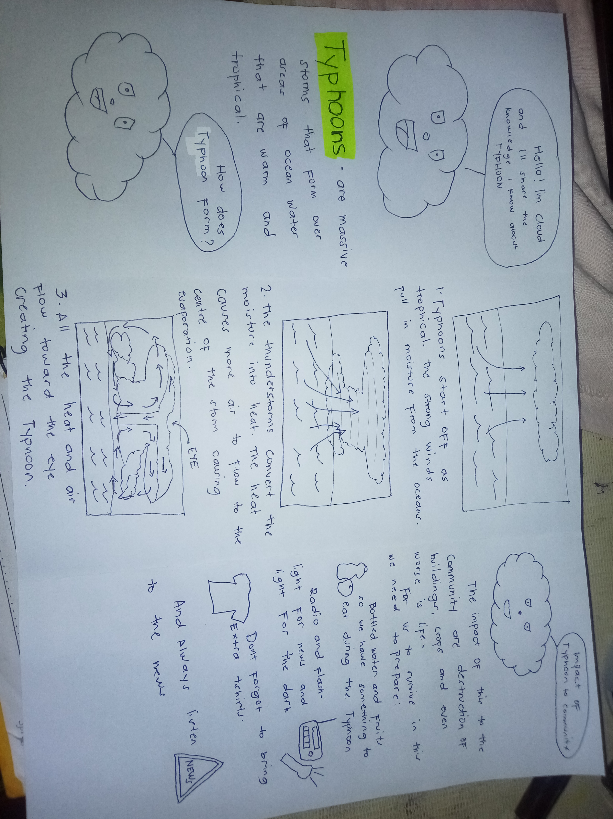**Performance task**

**REFLECTION QUESTION #3**

1. Can we expect lightning/thunder in such weather? Yes we can expect that there will be a lightning in a heavy rain.

2. Is Ali’s proposal correct? Why? In this case there are two possible answer. First if they will make it for their mother for Al it's okay, and the other is Ali's proposal is wrong because he didn't consider that they might be hit by the lightning.

3. What should the girls do if they are near the forest when the rain starts?

They should go first for a safety place where you can stay and don't run because of the slippery mud.

**Self check #3**

|  |  |
| --- | --- |
| **Questions** | **Answer** |
| What is a thunderstorm? | It is a type of storm with thunder and lightning and heavy rain |
| How does a thunderstorm form? | Thunderstorms form when warm, moist air rises into cold air. The warm air becomes cooler, which causes moisture, called water vapor, to form small water droplets - a process called condensation. The cooled air drops lower in the atmosphere, warms and rises again. This circuit of rising and falling air is called a convection cell. If this happens a small amount, a cloud will form. If this happens with large amounts of air and moisture, a thunderstorm can form. |
| What must be done to survive thunderstorm? | To survive in thunderstorm we must stay inside our house, plug out all the device or appliances , don't stay near window and avoid using devices |

**REFLECTION QUESTION #4**

Before the flood first is secure first all the important things in the house. Free the pets bring food and evacuate to near evacuation center. During the flood you need to be observant even if you are in evacuation center you can't predict what will happen so always prepare. After the flood don't run or play because of the slippery floor.

**Selfcheck#4**

Answer the following questions. Write your answer on the space provided below

1. Is there a difference between flood and flash flood? Explain your answer.

The flash flood is a type of flood that cause of heavy or excessive rain fall in a short time in approximately 6 hours that's why it's called called flash flood. While flood is a longer term event than flash flooding: it may last days or weeks.

2. What are the kinds of hazards that can cause flooding?

As an example for this are the illegal logging, throwing trash in an drainage, deforestation, and removal of coastal marshes/mangroves.

3. What are the factors that contribute to the occurrence of floods?

The main factor that contribute to the occurrence of floods is the rain, second is the physical activities of the people like cutting trees and lastly the dam.

4. Why is it important to know the flood warning or flood advisory?

It is very important for everyone to know the flood warning because in this case we can know if we need to evacuate and also this helps to ensure our safety and to avoid casualties.

5. Differentiate minor flooding from major flooding.

Minor flooding from a flood where doesn't have enough strength to threat a human on damage building there's a possibility for a minimal damage on other house but not that threatening while major floods are the big ones that poses a threat.

**REFLECTION QUESTION #5**

I will let know the locals that surrounds me that a storm surge gives a serious destruction so we need to evacuate for our safety in that way the news will spread fast because they will also share to other neighbors, I will also post on social media on what is a storm surge and it's effect after that is the advice to evacuate for the safety.

**Self check #5**

I.TRUE OR FALSE: Write STORM if the statement is correct, SURGE if it is wrong.

STORM 1. Storm surge is the masses of water that are pushed toward the shore by meteorological forces.

SURGE 2. Typhoon Sendong took away the lives of over 5081-8165 people.

SURGE 3. Storm surge is catastrophic when the heights from mean sea level are 2.1 to 3 meters high.

SURGE 4. The deadliest storm surge to hit the Philippines is typhoon Haiphong.

STORM 5. Storm surge is possible when mean sea level reached 1-2 meters high.

II.Answer the following questions. Write your answer on the space provided below.

1. What should you do if you are in a storm-surge prone area?

If I'm in a storm-surge prone area the first thing I will do is to get the most important files first, secure the house just like putting sack of gravel in the roof, also tell your neighbors to evacuate in a high place because of the storm surge and the last is to bring also the pets

**Self check #6**

I. Answer the following questions. Put your answer in the box below.

|  |  |
| --- | --- |
| Question | Answer |
| What is a landslide? | movement of rock, earth, or debris down a sloped section of land. |
| What contributes to the occurrence of landslide? | * Illegal logging * Illegal mining * Heavy rain * Earthquake |
| What must be done to survive landslide? | Avoid building house near the edge of a land, always observe the formation of the land, ask your neighbors if they already experienced landslide and ask them what to do incase there is one. And after that is make a plan incase a landslide occur. |
| What are the impacts of landslide to a community? | The impact of a landslide is loss of life, destruction of infrastructure, damage to land and loss of natural resources. Landslide material can also block rivers and increase the risk of floods. |

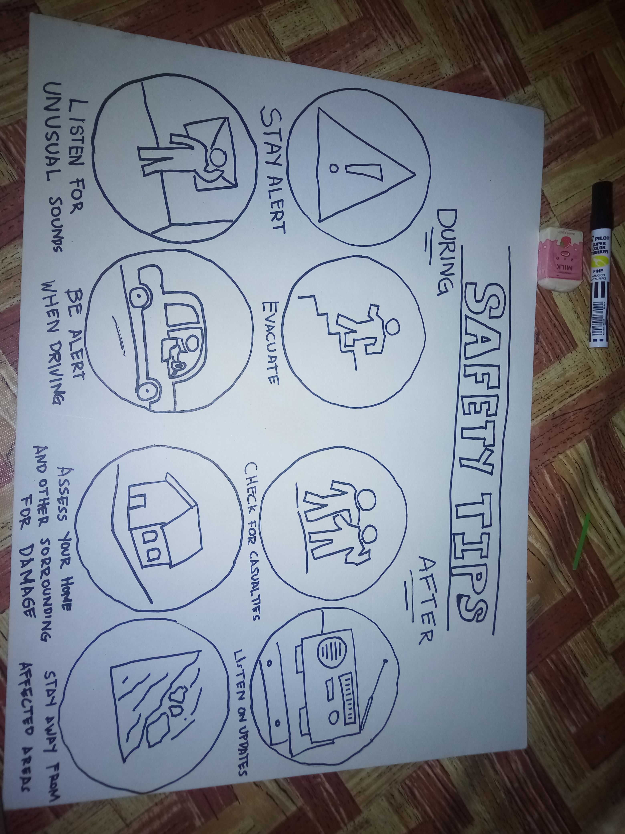**II. Performance Task**

**Self check #7**

Answer the following question. Write your answer on the space provided below.

1. What are the differences between El Niño and La Niña?

El niño is super heat type of weather that you can fill thirst every hour and also you can observe that there are so many break in the land because of lack in water while LA Nina is the opposite of El Niño where you can feel very cold sensation and always raining.

2. How do these affect the community? (5pts.) It affect the community both on that's farmland they suffer because for example during an El niño it is expected it will be a hot season and plants need more water to survive, while LA niña also devastate the plants because to much water will ruin the crops.

3. What are the things you should do when there are El Niño and La Niña?

During El Niño we should prepare for mid kits, radio powered battery, foods, and always secure the house because it is expected that during an El niño a typhoon is expected then during a LA Nina always check the vases for mosquito larvae and expect that there will be a long rain event.